# The bases

## Quotes use (\” vs ‘)

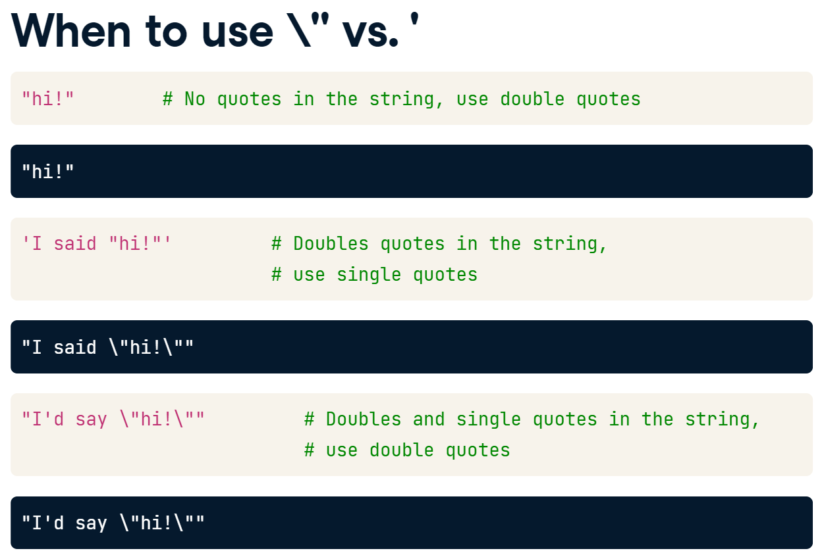

## Printing strings

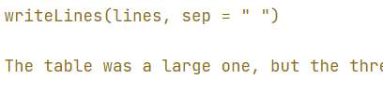

## Escape sequences

**\":** Denote a double quote.

**\n**: Gives a new line.

**\U:** Followed by up to 8 hex digits sequence denotes a particular Unicode character.

**\u:** Only need four digits for the codepoint. http://www.unicode.org/charts/

**\\:** To keep a backlash in the text.

## Unicode

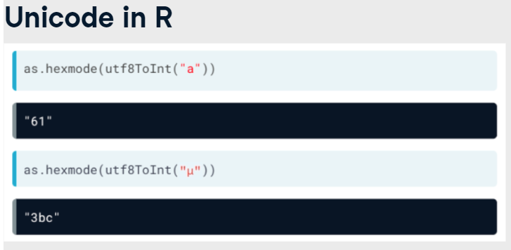

**stri_trans_nfc():** Composes characters with combining accents into *a single character*.

**stri_trans_nfd():** Decomposes character with accents into *separate letter and accent* characters.

In Unicode, an accent is known as a diacritic Unicode Property, and you can match it using the rebus value UP_DIACRITIC

# Functions with patterns in stringr

**stri_read_lines(): or readLines()**

**str_which(text, ___):**

**stri_isempty()**

**fixed(**“text”**):** Is useful if you are looking for patterns that contain punctuation like dots, dashes, brackets and slashes.

**str_detect() or %like% :** Answers the question “Does the string contain the pattern?”.

**str_sub():** Takes a subset of text by positions. It has the ability to use negative indexes to count from the end of a string.

str_sub(all_names, -2,-1): Last two letters.

str_sub(all_names, 1,1): First two letters

**str_subset() or grep():** We get a new vector of strings, but it only contains those original strings that contained the pattern.

**str_extract():** Returns a vector of the same length as that of the input vector.

**str_count() or nchar():** Answers the question "How many times does the pattern occur in each string?"

En el pattern podemos pasar un vector con diferentes patrones para tener multiples respuestas.

**str_split():**

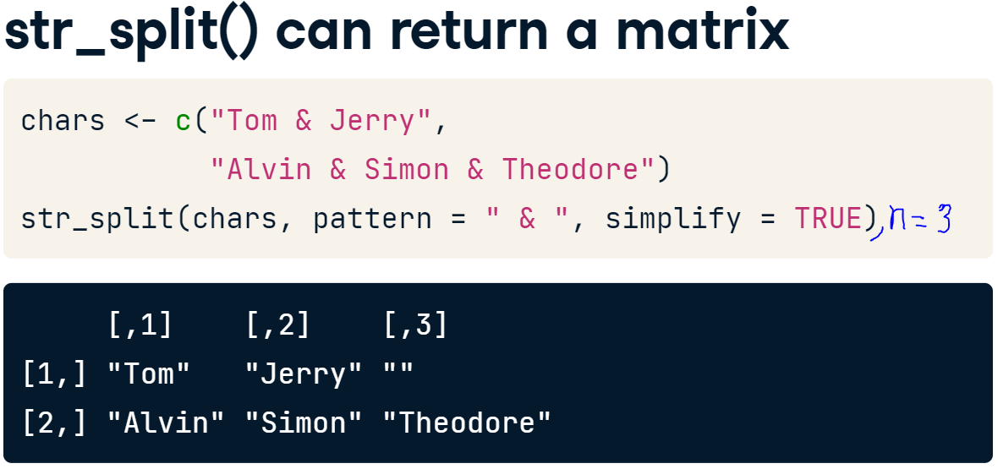

**str_length():** Says how long is a string.

**lapply(words, str_length):** count the number of characters in each word.

**str_replace():** replaces ***a*** pattern in the input strings with a specified replacement string.

**str_replace_all():** replaces ***all*** pattern in the input strings with a specified replacement string.

**str_remove():**

**str_view(match = TRUE):** It takes a string, and a pattern, and will open an HTML view with any matches to the pattern highlighted.

**regex(pattern, ignore_case = TRUE):**

**stri_trans_totitle():** Allows a specification of the type which, by default, is "word", resulting in title case, but can also be "sentence"

**str_extract():**

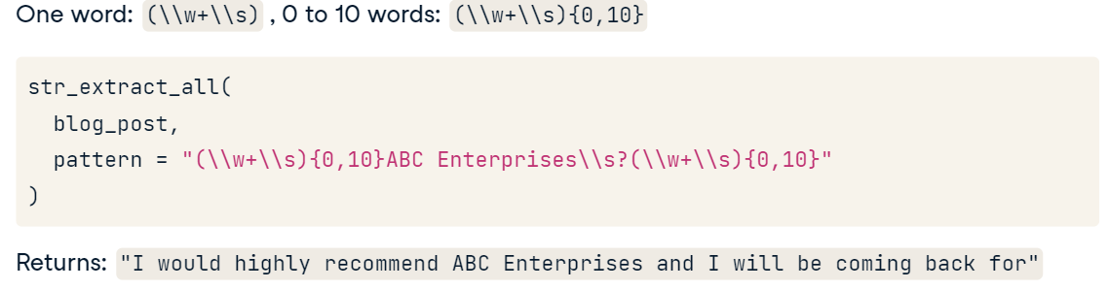

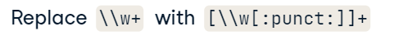

**str_match():**

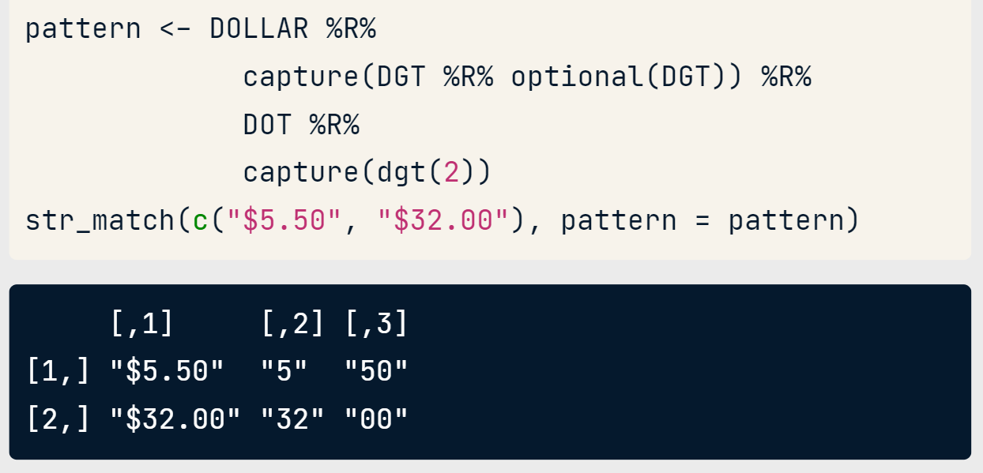

returns first the complete match and then the values for each capturing group.

str_match_all(): return a list and lapply can use this information.

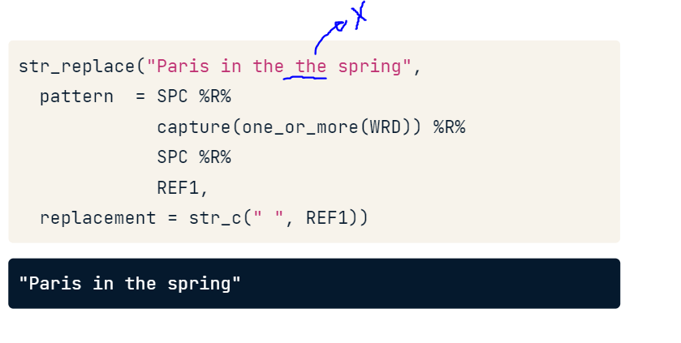

**tidyr::extract():**

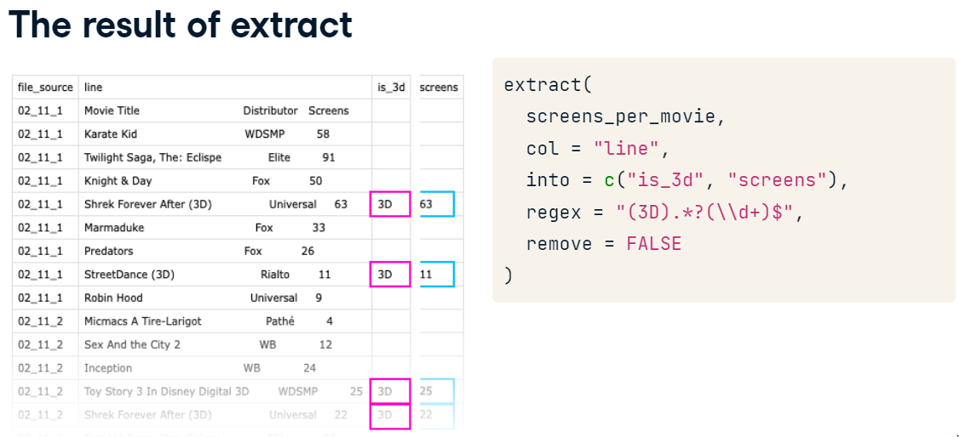

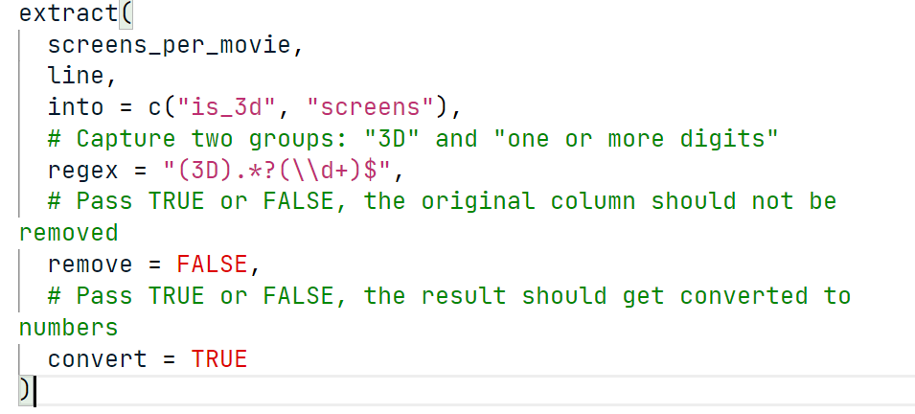

# Glue package

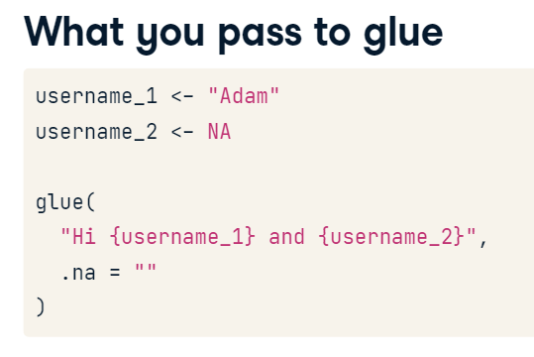

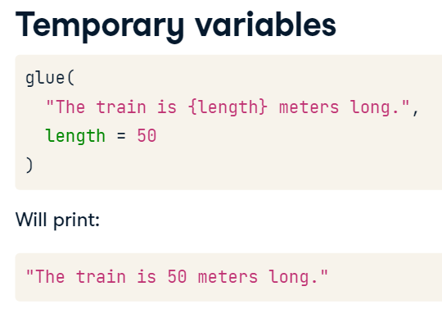

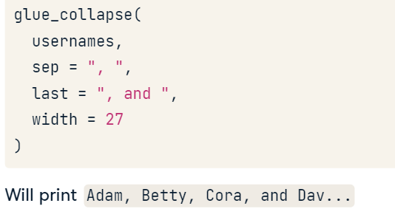

## Documenting a regular expression

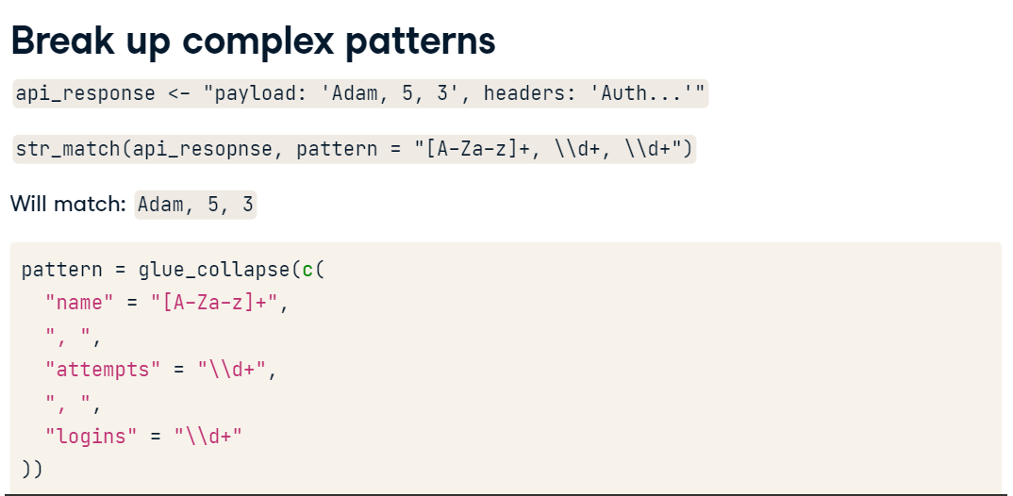

# Regular expressions

|  |  |  |
| --- | --- | --- |
| **Pattern** | **Regular Expression** | **rebus** |
| Then |  | %R% |
| Start of string | ^ | START |
| End of string | $ | END |
| Limita a que en el texto solo se vea el patrón | ^algo$ | exactly(“algo”) |
| One letter | . | ANY_CHAR |
| One lower letter |  | LOWER |
| Letters, numbers or underscores | \\w | WRD |
| A word | (\\w+\\s) |  |
| NOT Letters, numbers or underscores | \\W |  |
| Words | [A-Za-z] |  |
| Letras mayusculas |  | ascii_upper() |
| Digits | \\d | DGT |
| NOT digits | \\D |  |
| Accents |  | UP_DIACRITIC |
| Encuentra todas las letras tengan o no acento |  | GRAPHEME |
| Many white space, \t and \n | \\s | SPC |
| NOT Many white space, \t and \n | \\S |  |
| Literal dot, carat, dollar, Backreferences | \\., \\^, \\$, \\1-9 | DOT, CARAT, DOLLAR, REF1-9 |
| Todos los signos de puntación | [:punct:] |  |
| [A-Za-z] upper and lower case letters  [0-9] all numbers between 0-9  [Ss]hot (example- shot with caps or not) | [character_list] | char_class(pattern) |
| The first that don’t match | [^character_list] | Negated_char_class(pattern) |
| Used to identify groupings | () | capture() |
| Alternation | | | or(pattern1,pattern2) |
| one of the characters |  | or1(letters) |
| will only match if it occurs as a word on its own |  | whole_word("cat") |
| To extract numbers in a certain range |  | number_range() |
| To specify common date patterns |  | datetime() |
| **Repetition** | | |
| Match 0 - infinity times (Not sure) | * | zero_or_more() |
| Match 1 to infinity times (Sure) | + | one_or_more() |
| Match 0-1 times (Optional) | ? | optional() |
| Makes lazy our patterns from a greedy form | ? |  |
| Between m and n times | {m,n} | repeated() |
| Une or two digits  Two or more digits | \\d{1,2}  \\d{2,} | dgt(1, 2) |

# Use this pattern

three_digits <- DGT %R% DGT %R% DGT

four_digits <- three_digits %R% DGT

separator <- char_class("-.() ")

phone_pattern <- optional(OPEN_PAREN) %R%

  three_digits %R%

  zero_or_more(separator) %R%

  three_digits %R%

  zero_or_more(separator) %R%

  four_digits

one_or_more("\\d") %R% zero_or_more(" ") %R% or("YO","YR","MO")

If you want a challenge, get the neiss package and see if you can extract age and gender from all accidents.

# stringdist package

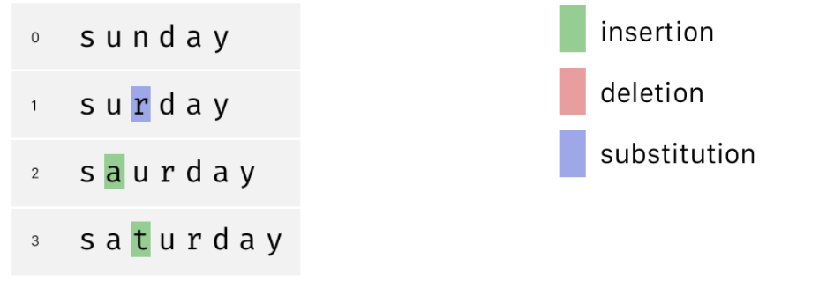

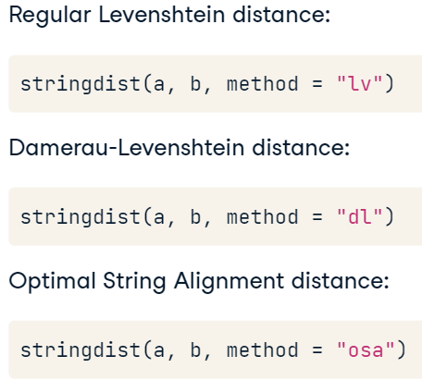

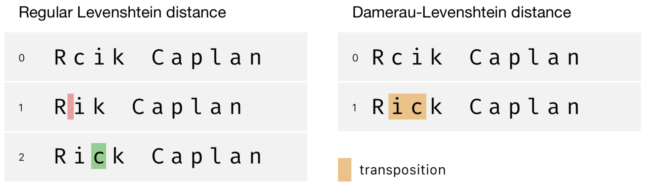

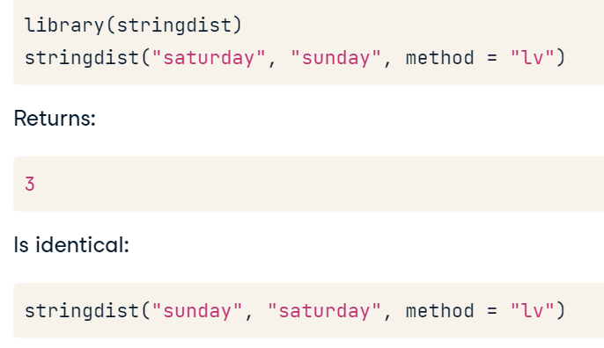

**amatch():** Tells us if a search input "x" can be found in a vector "table" (vector).

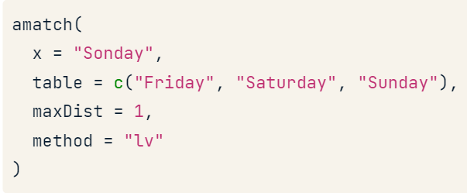

"Qgrams" are overlapping substrings of a certain length, but this sounds more complicated than it is.

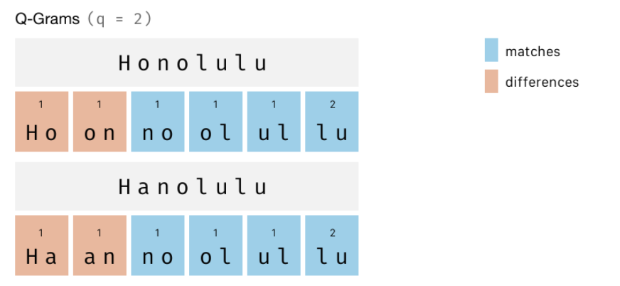

It is just **the sum of all qgrams that are not shared**, so in our case: 4. These are the orange ones.

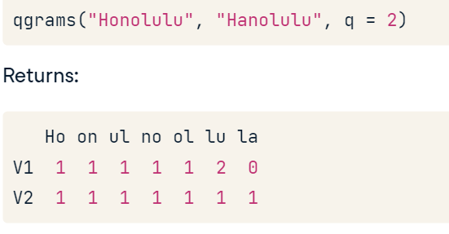

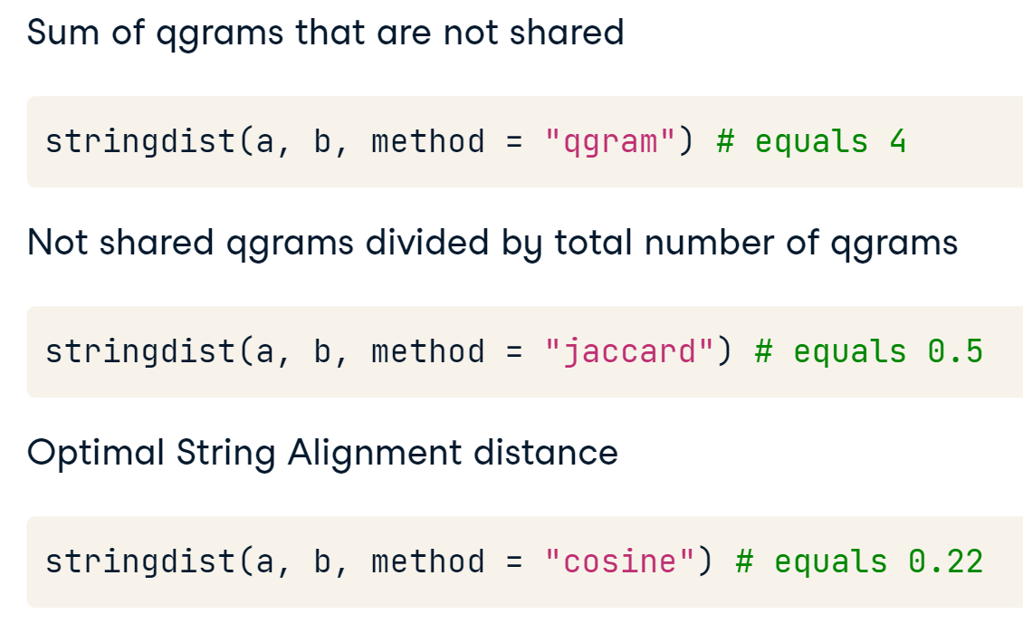

# fuzzyjoin package

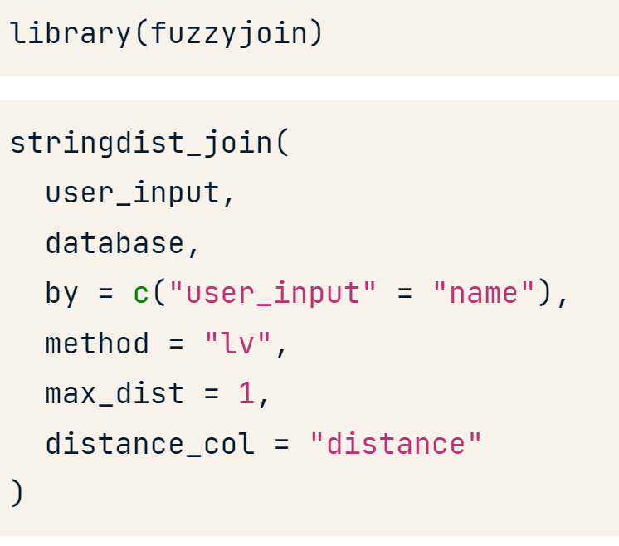

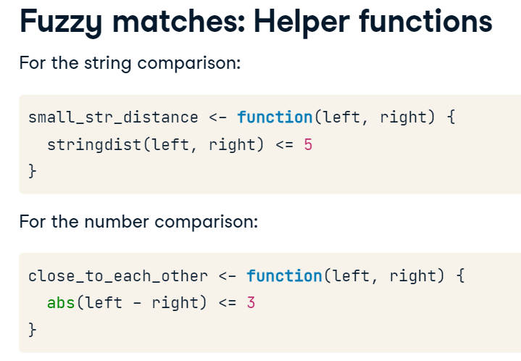

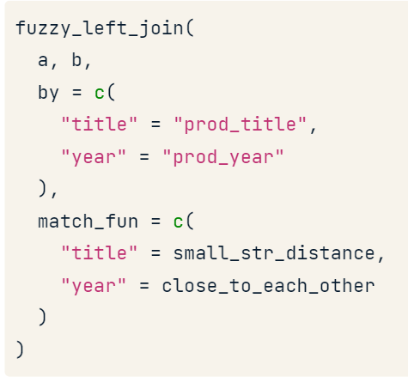

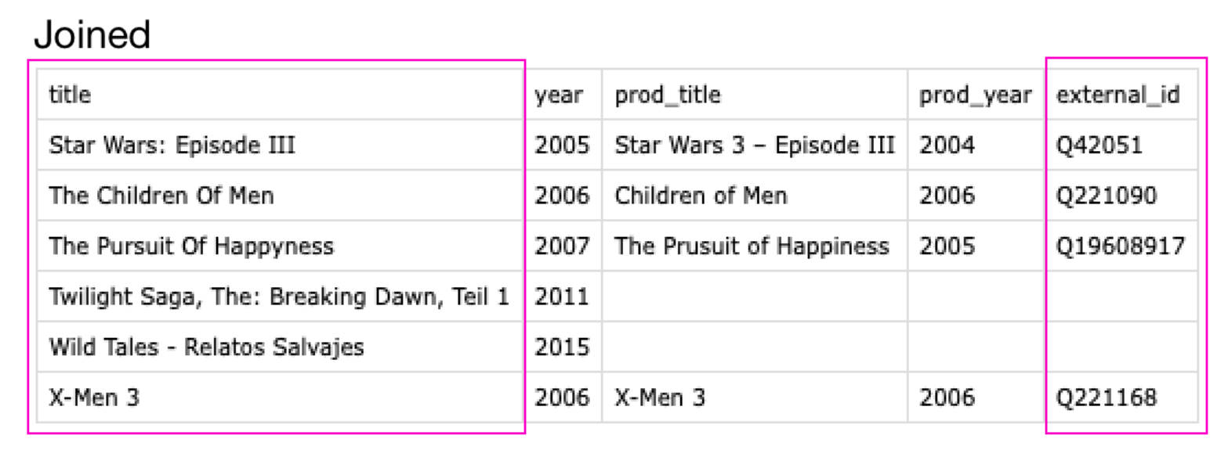

# Text mining

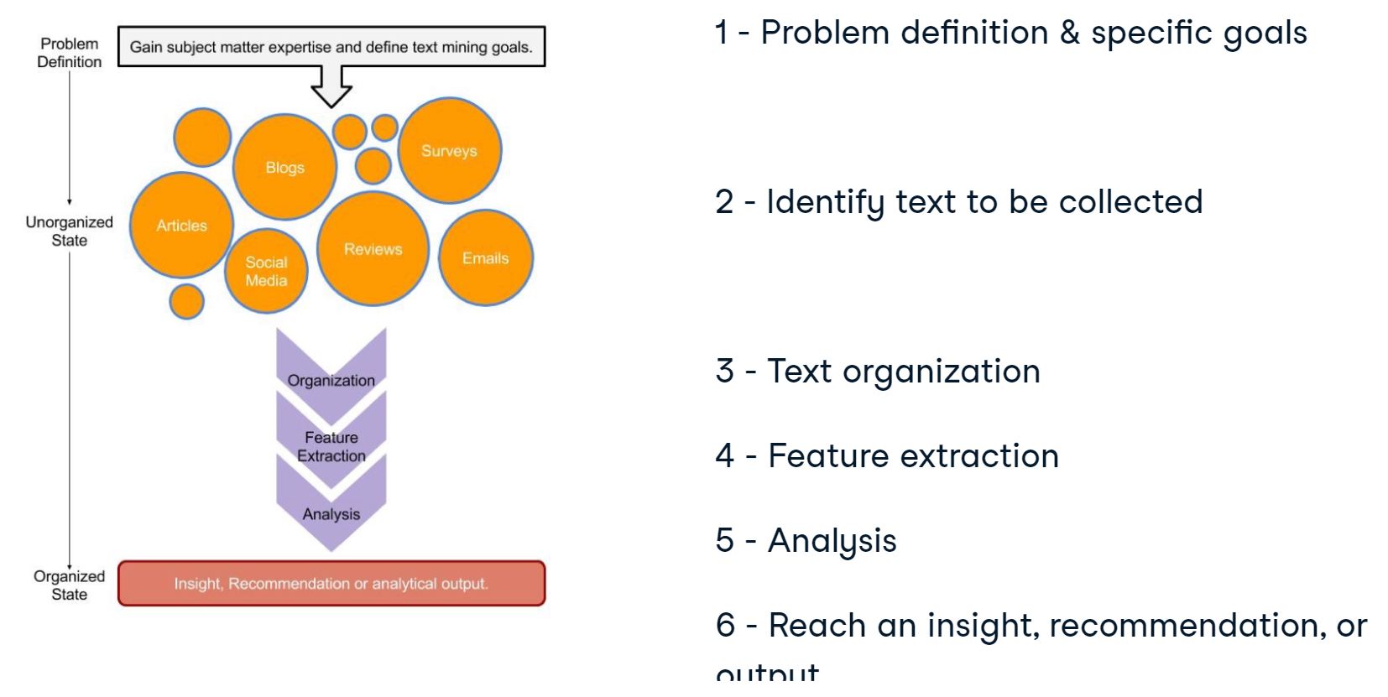

## Extracting data from a book

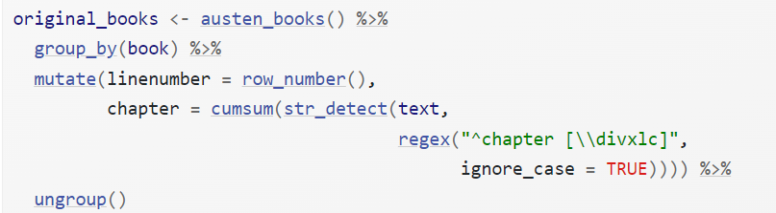

We use **str_extract()** here because the UTF-8 encoded texts from Project Gutenberg have some examples of words with underscores around them to indicate emphasis (like italics). The tokenizer treated these as words, but we don’t want to count ***“_any_”*** separately from ***“any”*** as we saw in our initial data exploration before choosing to use str_extract().

## Cleaning text

### qdap

The **qdap** package offers other text cleaning functions. Each is useful in its own way and is particularly powerful when combined with the others.

**bracketX():** Remove all text within brackets (e.g. "It's (so) cool" becomes "It's cool")

**replace_number()**: Replace numbers with their word equivalents (e.g. "2" becomes "two")

**replace_abbreviation()**: Replace abbreviations with their full text equivalents (e.g. "Sr" becomes "Senior")

**replace_contraction()**: Convert contractions back to their base words (e.g. "shouldn't" becomes "should not")

**replace_symbol()** Replace common symbols with their word equivalents (e.g. "$" becomes "dollar")

### tm

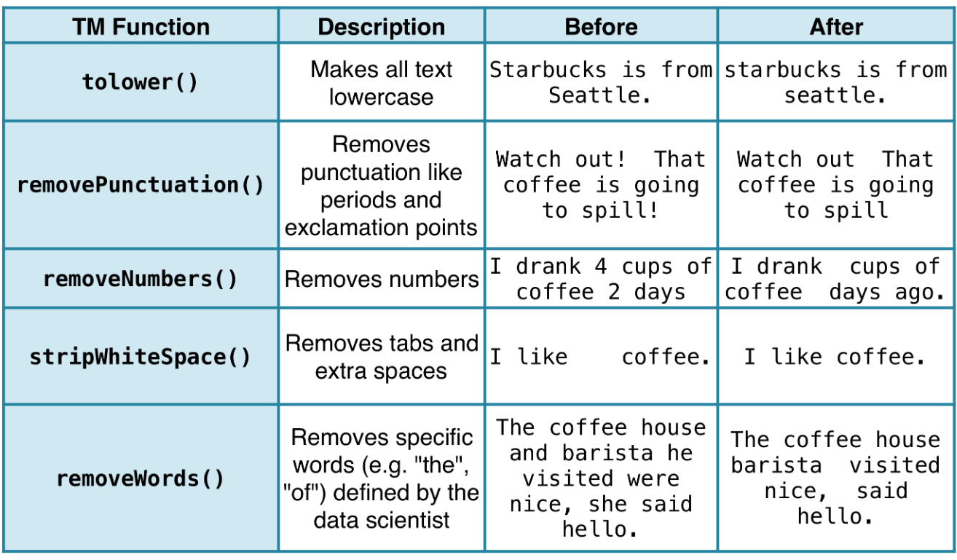

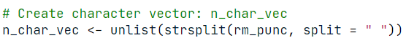

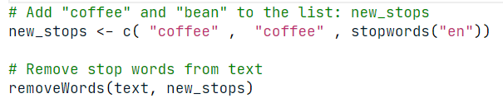

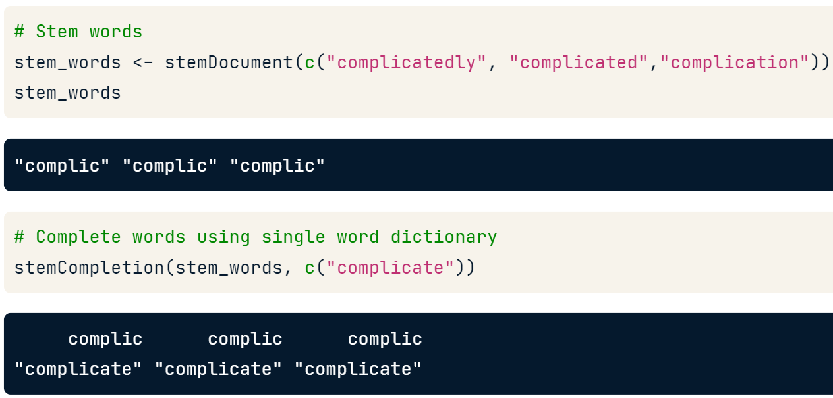

#### Cleaning a corpus

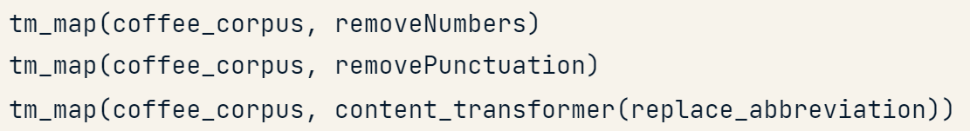

## Tokenizing text

### tidytext

We don’t care about the syntax or structure of the reviews, we’re simply cutting out each word in each review and mixing them up in a bag: a bag of words!

* Each separate body of text is a document; in this case, the reviews.
* Each unique word is known as a term.
* Every occurrence of a term known as a token;
* thus cutting up documents into words is known as tokenizing.

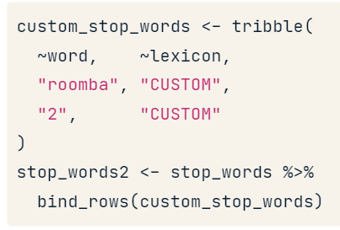

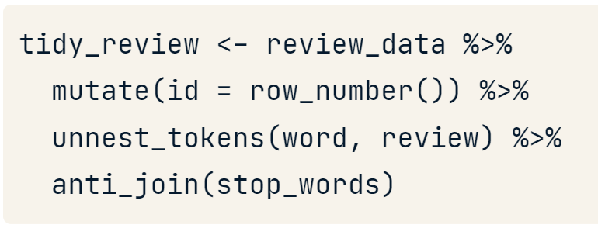

**Getting twiter**

reg <- "([^A-Za-z\\d#@']|'(?![A-Za-z\\d#@]))"

# Unnest the text strings into a data frame of words

tweet_words <- cleaned_tweets %>%

filter(!str_detect(text, '^"')) %>%

mutate(text = str_replace_all(text, "https://t.co/[A-Za-z\\d]+|&amp;", "")) %>%

unnest_tokens(word, text, token = "regex", pattern = reg) %>%

filter(!word %in% stop_words$word,

str_detect(word, "[a-z]"))

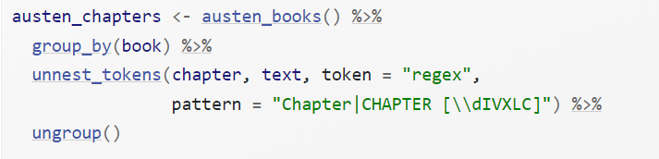

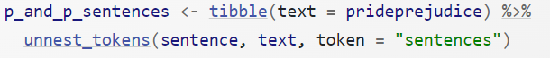

### qdap

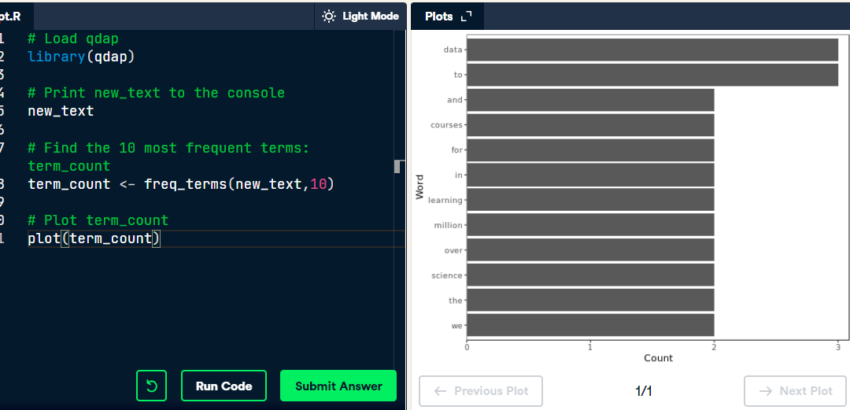

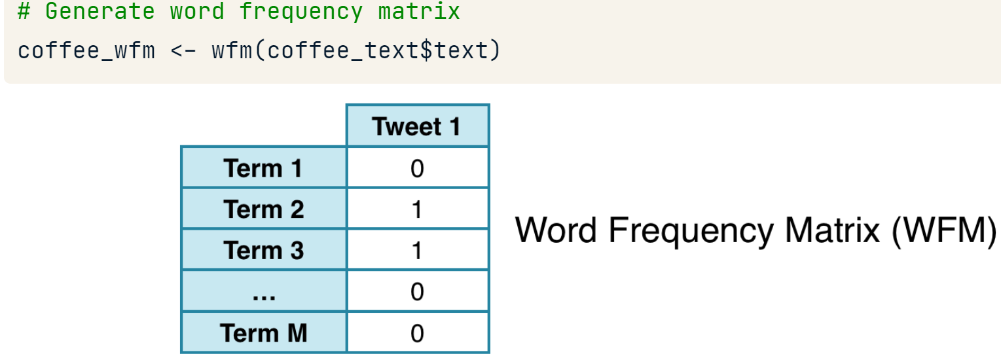

### tm

#### One word token

**FROM a vector**

coffee_source <- VectorSource(coffee_tweets)

coffee_corpus <- VCorpus(coffee_source)

**FROM a data.frame**

If your text data is in a data frame, you can use DataframeSource() for your analysis. The data frame passed to **DataframeSource()** must have a specific structure:

* Column one must be called **doc_id** and contain a unique string for each row.
* Column two must be called **text** with "UTF-8" encoding (pretty standard).
* Any other columns, **3+,** are considered metadata and will be retained as such.

df_source <- DataframeSource(example_text)

df_corpus <- VCorpus(df_source)

# Print the contents of the 15th tweet in coffee_corpus

coffee_corpus[[15]][1]

content(coffee_corpus[[15]])

meta(df_corpus)

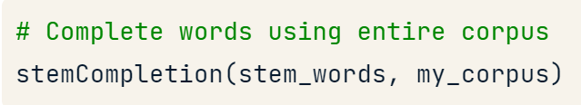

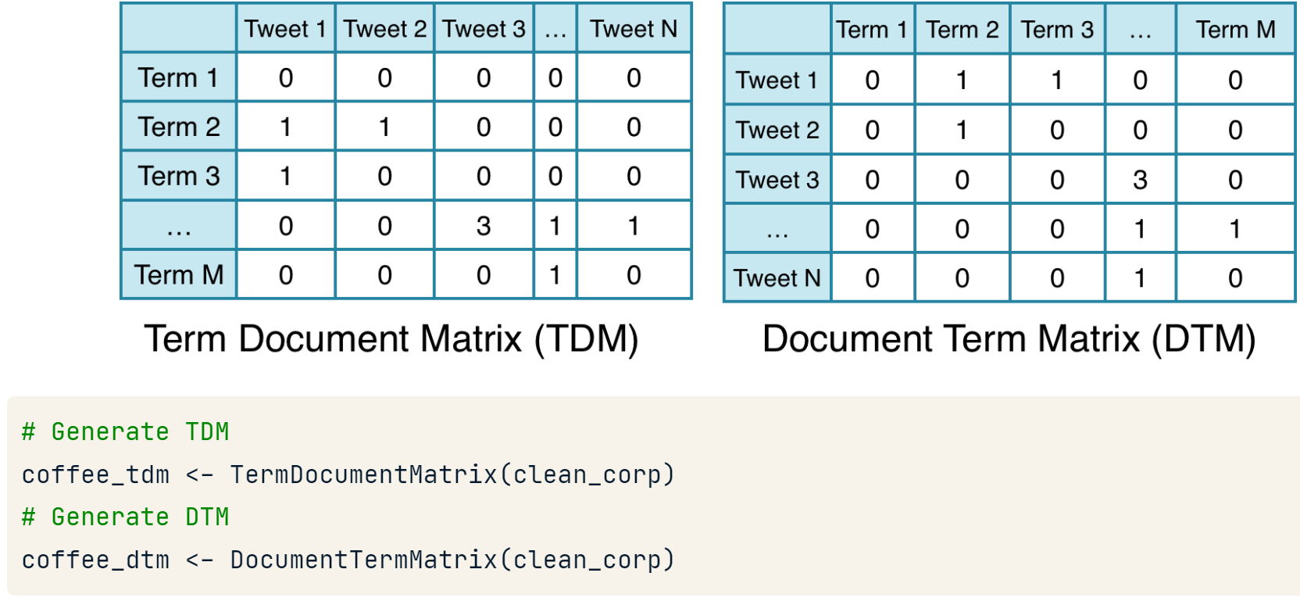

**Let’s keep metadata**

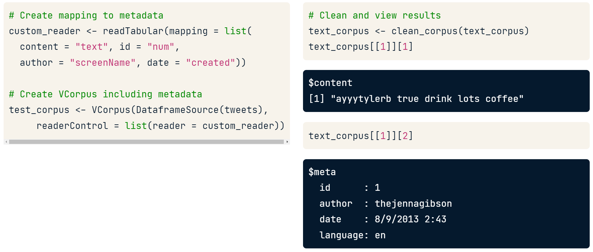

With a class "simple triplet matrix" but we can apply as.matrix()

To change a DTM to a tidy format use **tidy()** from the **broom** package.

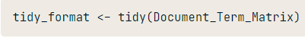

#### n gram tokes

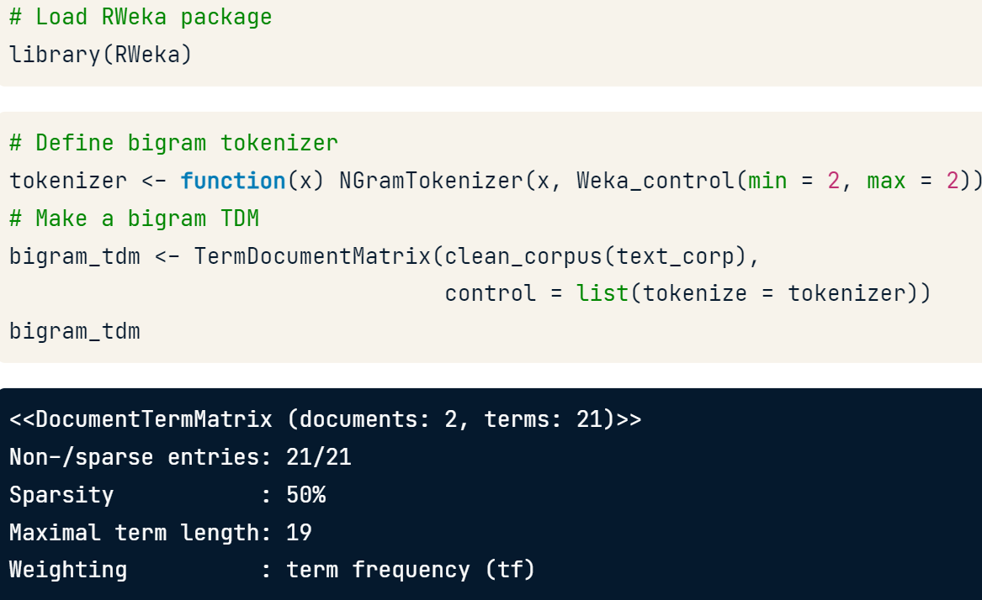

#### term weighting

**TFIDF,** or Term Frequency Inverse Document Frequency method. Essentially words are counted but penalized if they appear in a lot of documents. The thought being that words that are both common and across all documents have little informational value.

**TfIdf** counts terms (i.e. Tf), normalizes the value by document length and then penalizes the value the more often a word appears among the documents.

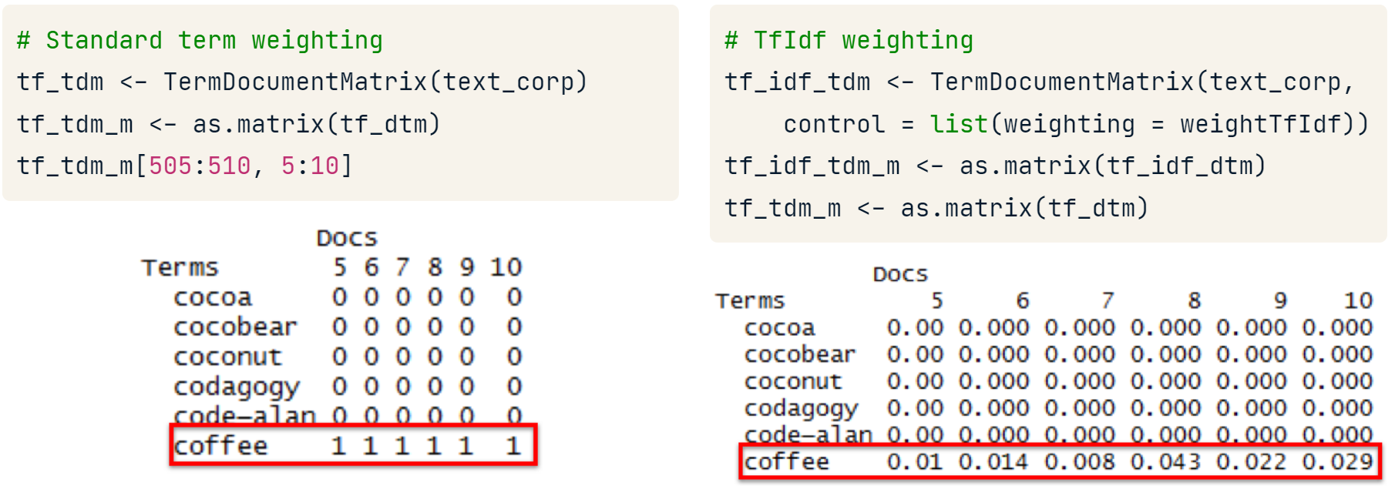

## Useful statistics

### Log odd ratio

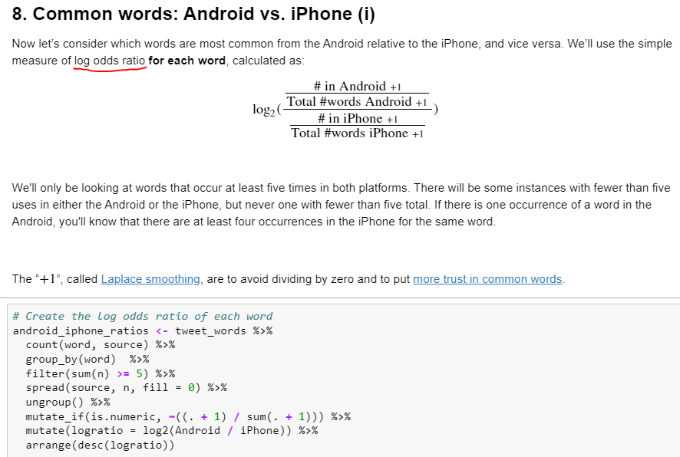

## Sentiment analysis

George Zipf created **“Zipf’s law”.** It states that given some text, the frequency of any single word is inversely proportional to its rank in the frequency table. More simply, if you counted up the word frequency in a passage, the second word would appear about half as much, fifty percent, as the first. One over the word's place on the list or one over two. Similarly, the third most frequent word could appear one third as much as the first and so on.

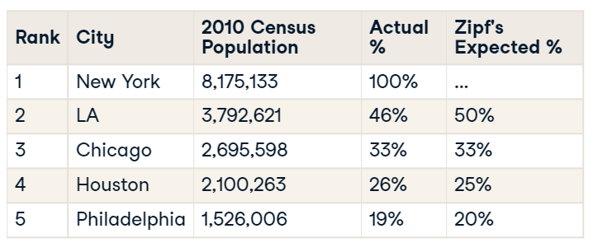

sb_words$expectations <- sb_words %$% {freq[1] / rank}

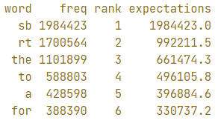

**“the principle of least effort”** from library sciences. A speaker or writer doesn't want to exert a lot of effort when communicating while the audience doesn't want to spend a lot of energy interpreting. So the word choice or lexical diversity becomes limited.

### lexicon

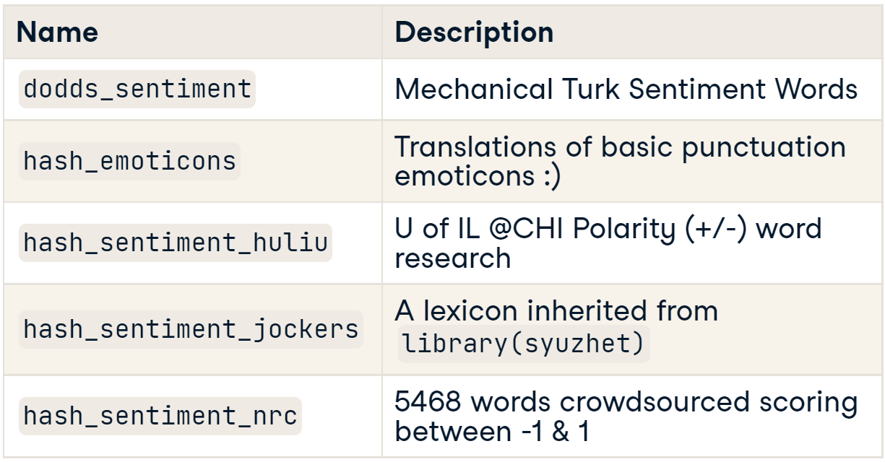

### tidytext

**Limitations**

* This method does not consider sarcasm or negated text
* To avoid positive and negative words have a 0 mean effect we should use short documents like sentences and paragraphs.

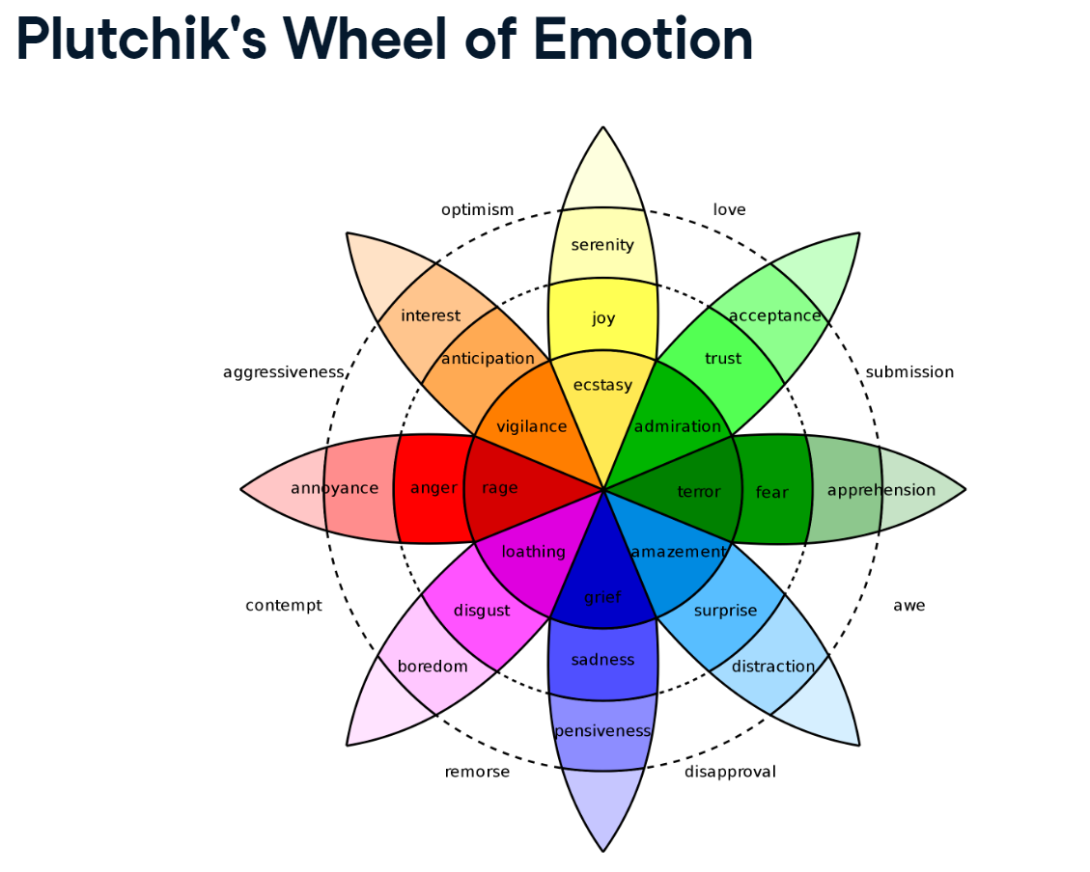

|  |  |
| --- | --- |
|  |  |
|  | |

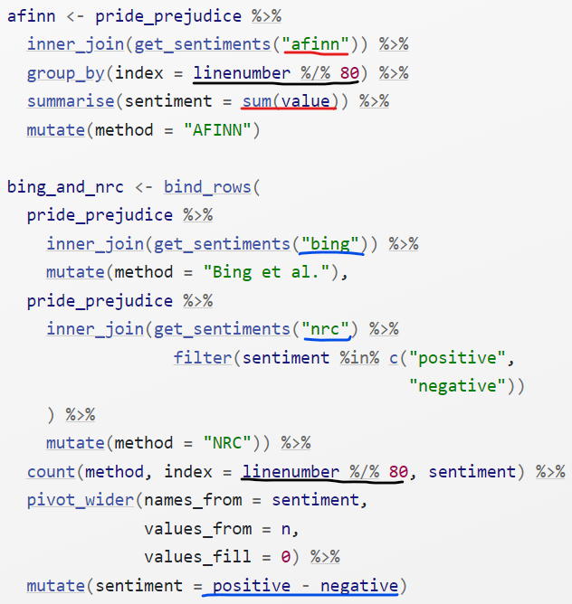

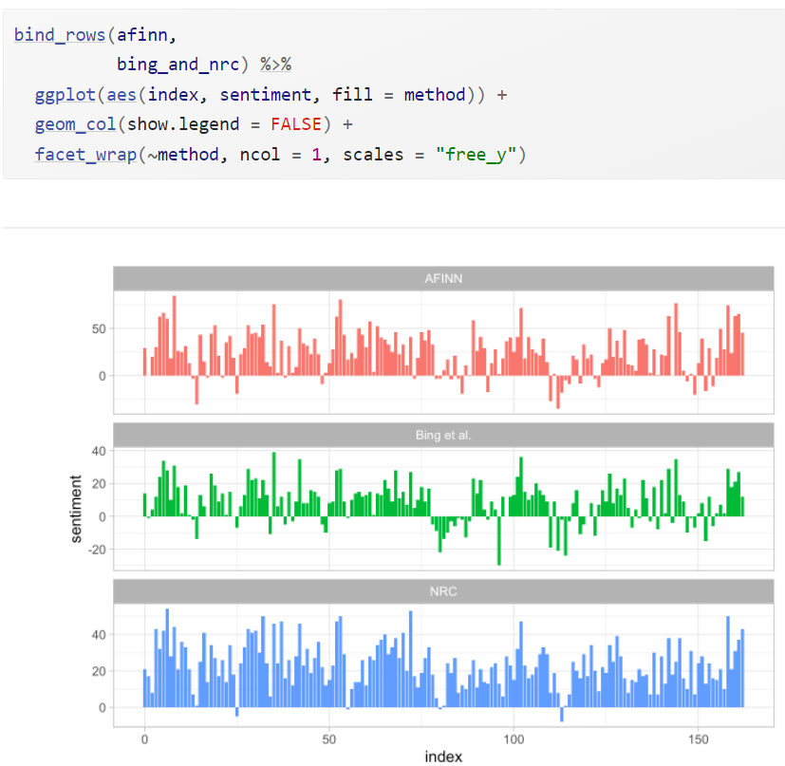

### qdap

**Getting a summary for all text**

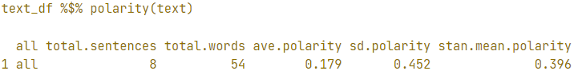

result$all is a data.frame with every polarity result.

**Getting a summary per group**

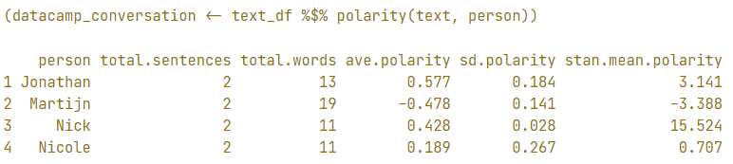

**Changing the dictionary**

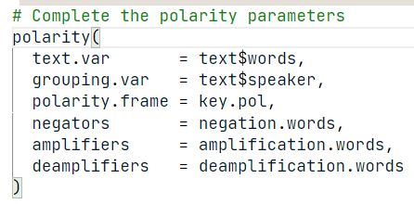

I could be necessary to **scale()** our polarity result as more negative o positive comments comes from authors that made for effort to write their comments.

**plot(datacamp_conversation)**

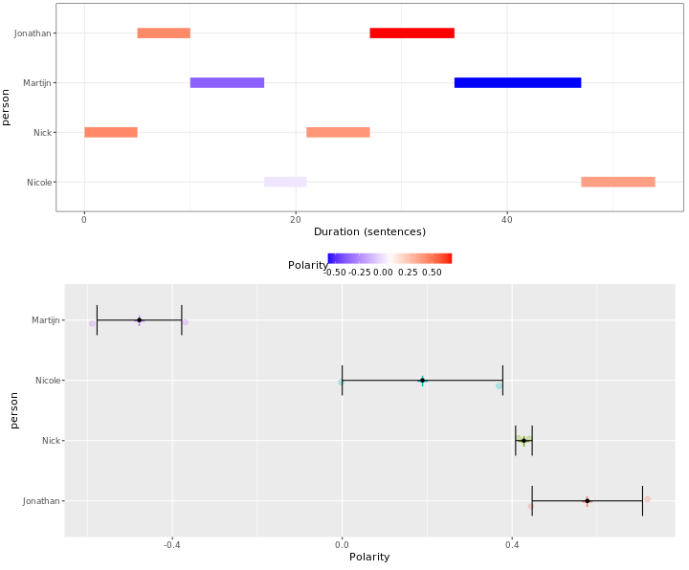

**counts()** to print the specific emotional words that were found.

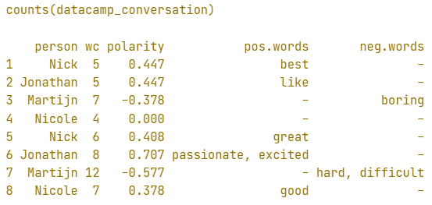

**How does it work?**

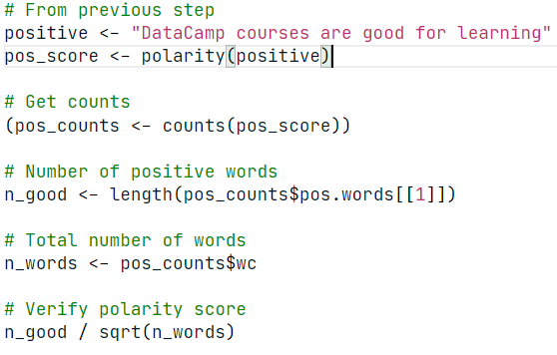

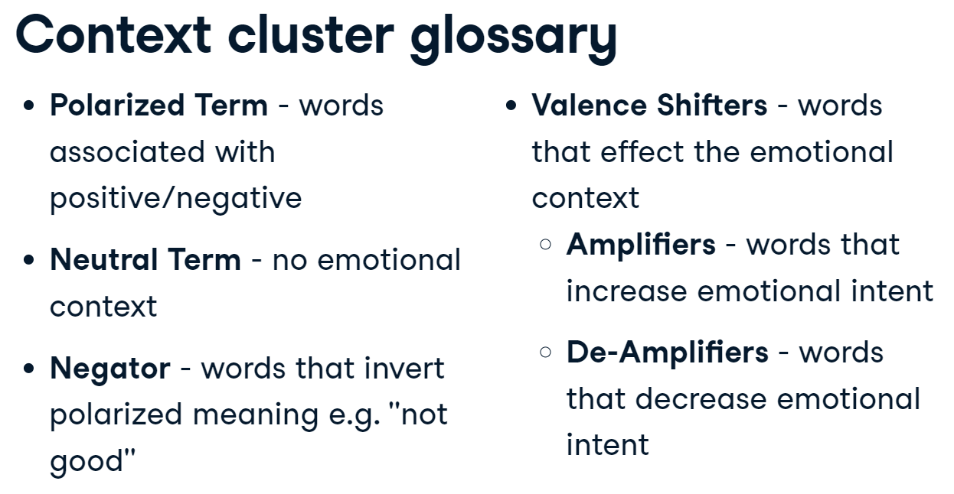

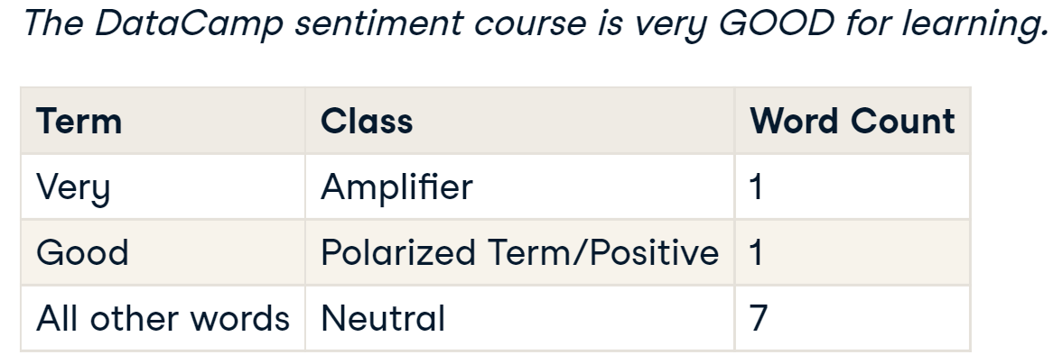

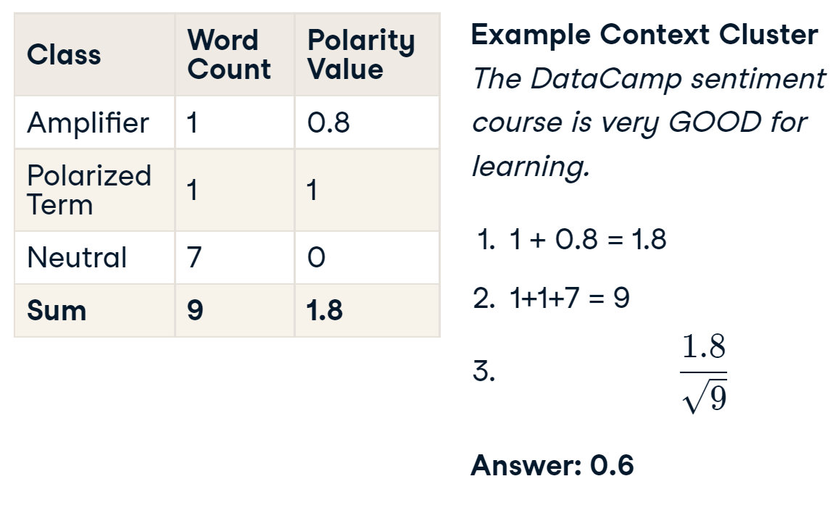

**Adding new negative/positive words**

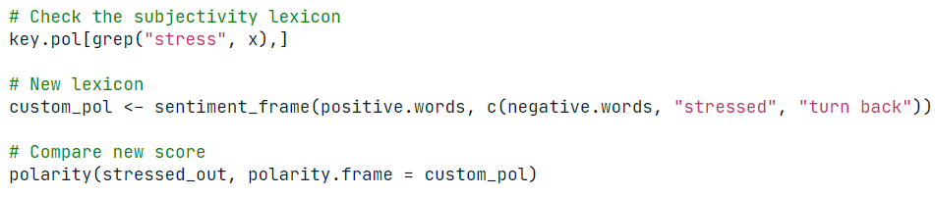

## Creating plots

### Scatter plot

#### ggplot2

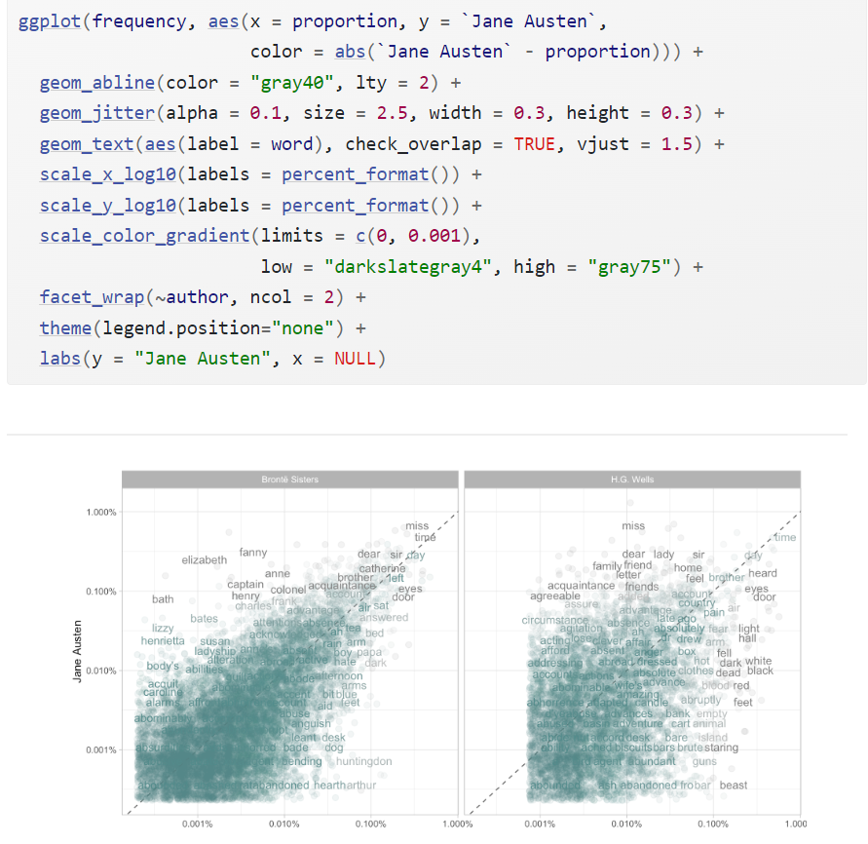



### Calculating correlation

#### Base R

How correlated are the word frequencies between Austen and the Brontë sisters, and between Austen and Wells?

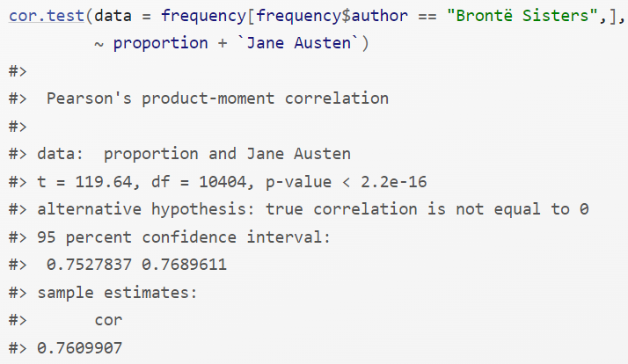

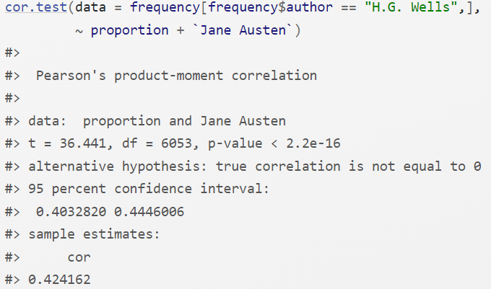

#### tm

**findAssocs()** calculates its correlation with every other word in a TDM or DTM at document level. Scores range from 0 to 1. A score of 1 means that two words always appear together in documents, while a score approaching 0 means the terms seldom appear in the same document.

Minimum correlation values are often relatively low because of word diversity. Don't be surprised if 0.10 demonstrates a strong pairwise term association.

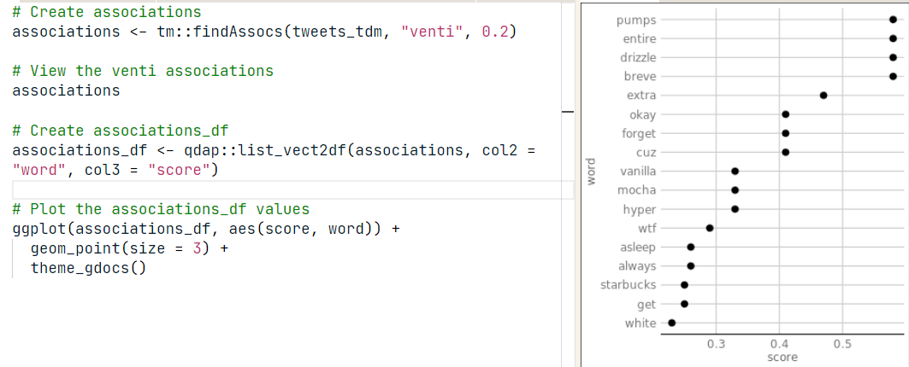

### Bar plot

#### ggplot2

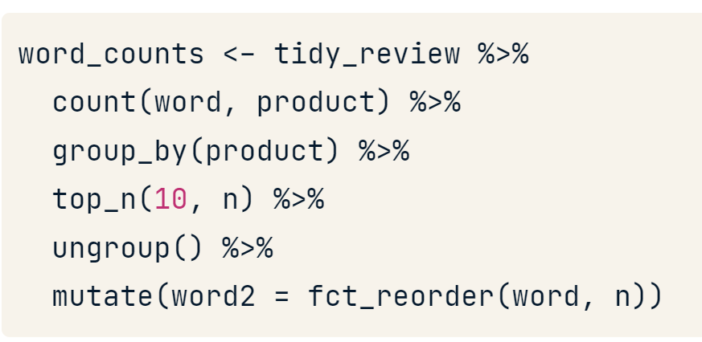

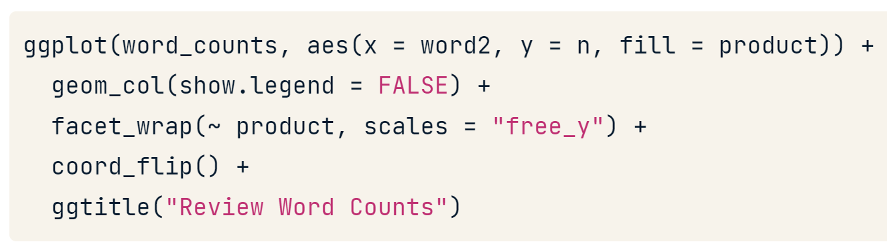

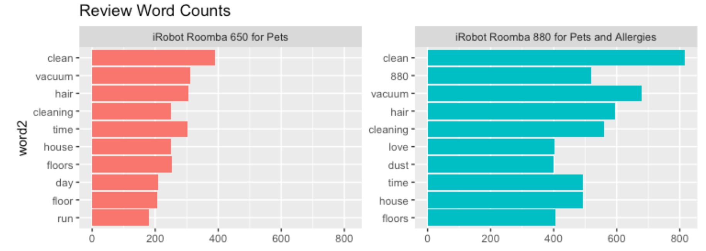

#### tm

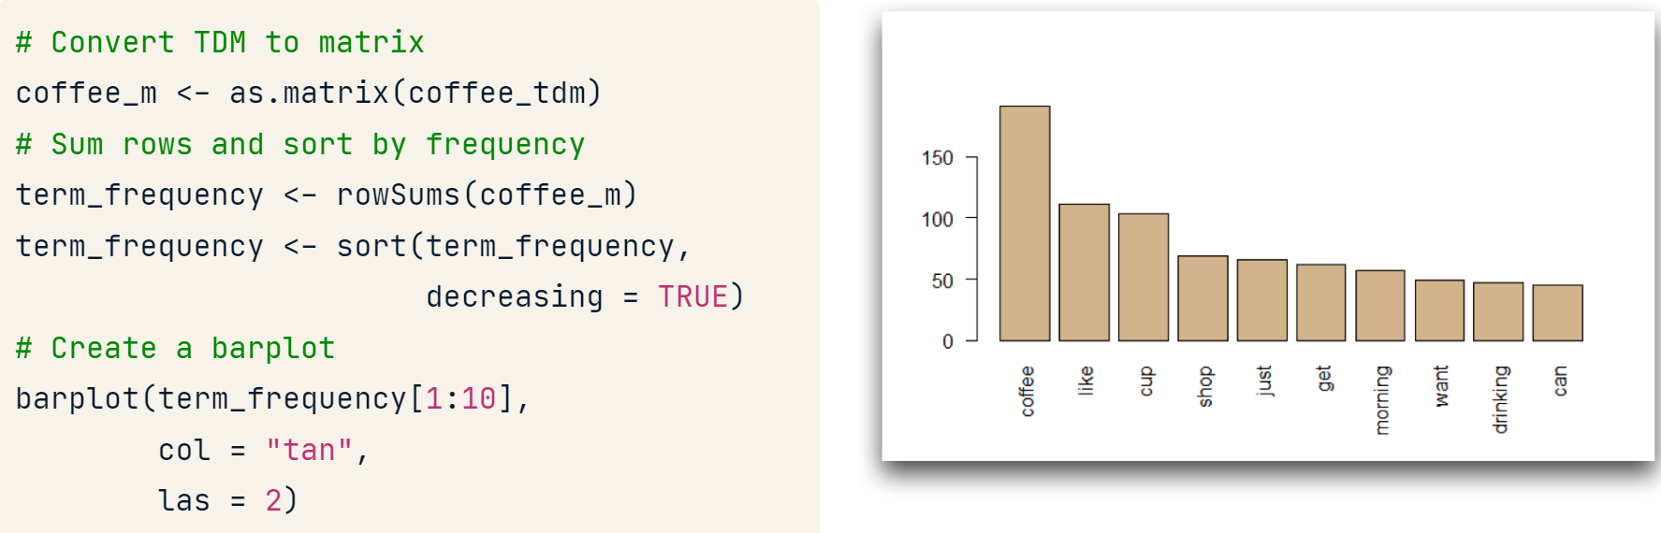

#### qdap

* Limit to the top 10 terms.
* At least three letters per term.
* Use "Top200Words" or stopwords("english") to define stop words

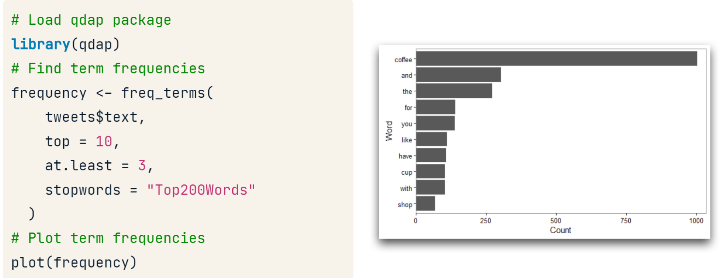

### Line plot

We can plot a smooth line to check the polarity over time or lines of a book.

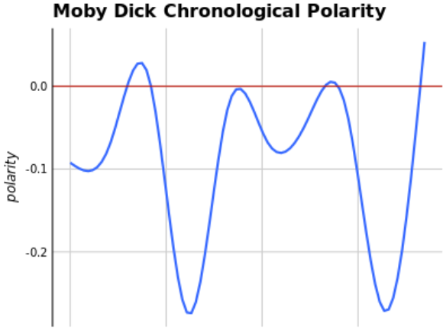

### Wordclouds

#### tm

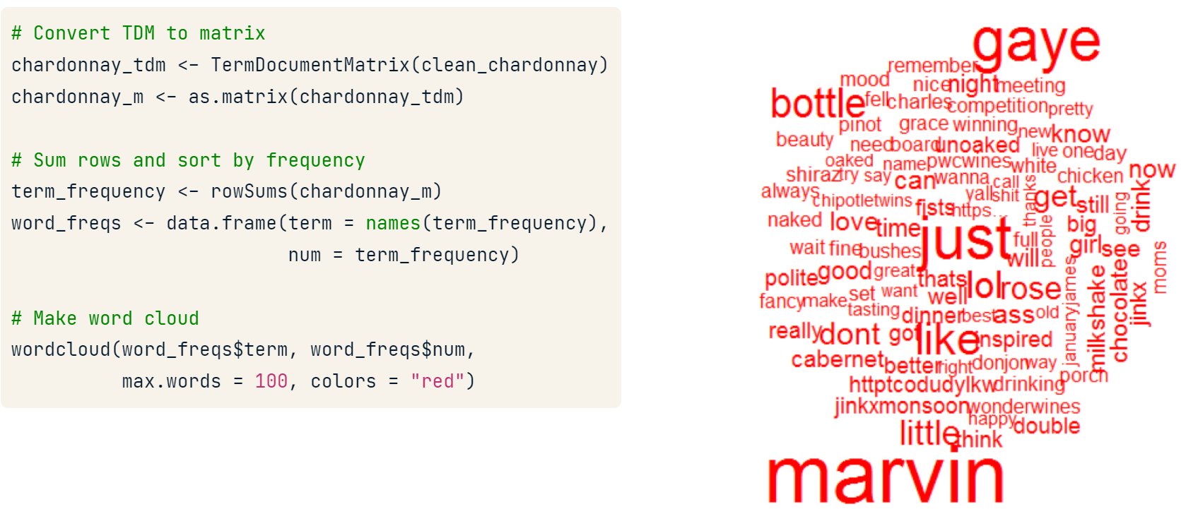

#### tidytext

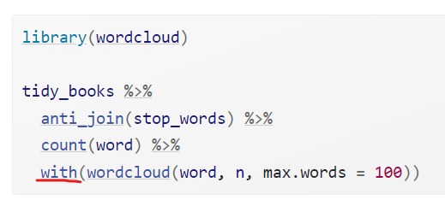

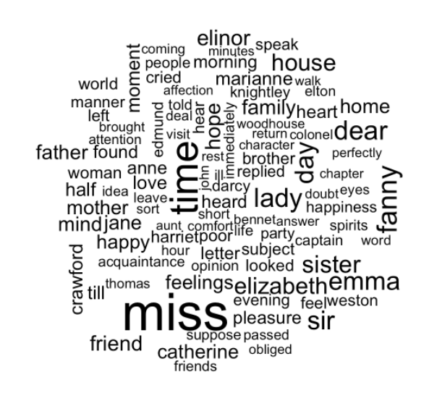

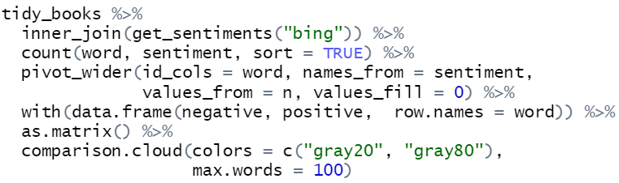



#### Advanced clouds

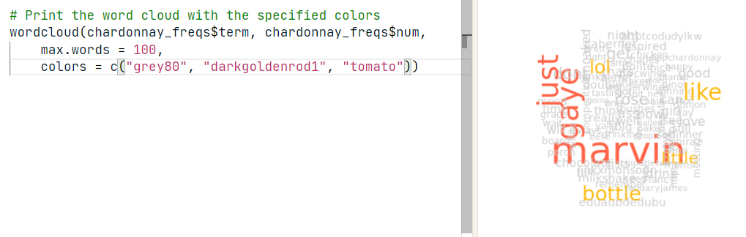

To find the intersection in a commonality-dot-cloud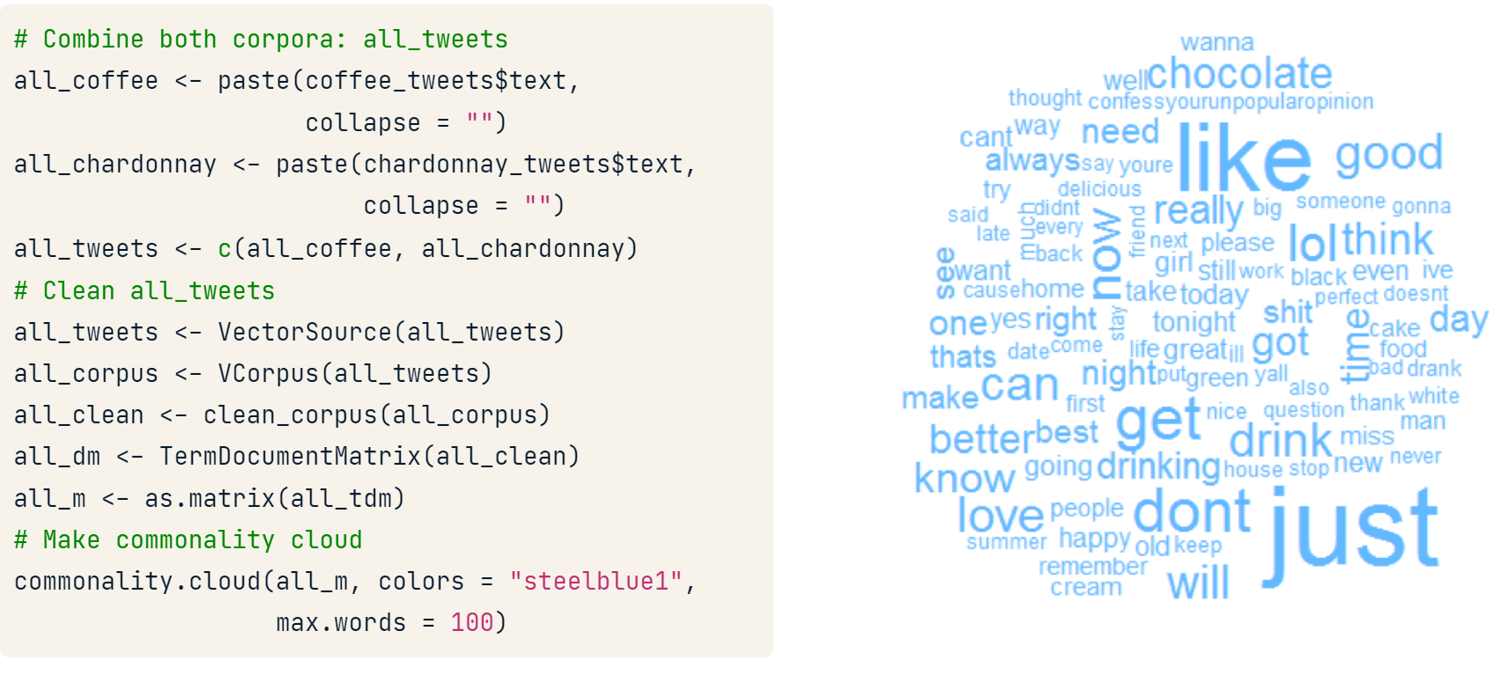

To understand the disjunction of the two documents.

* *the sizes of the words are not comparable across sentiments.*
* We can compare polarity by taking out words with polarity == 0

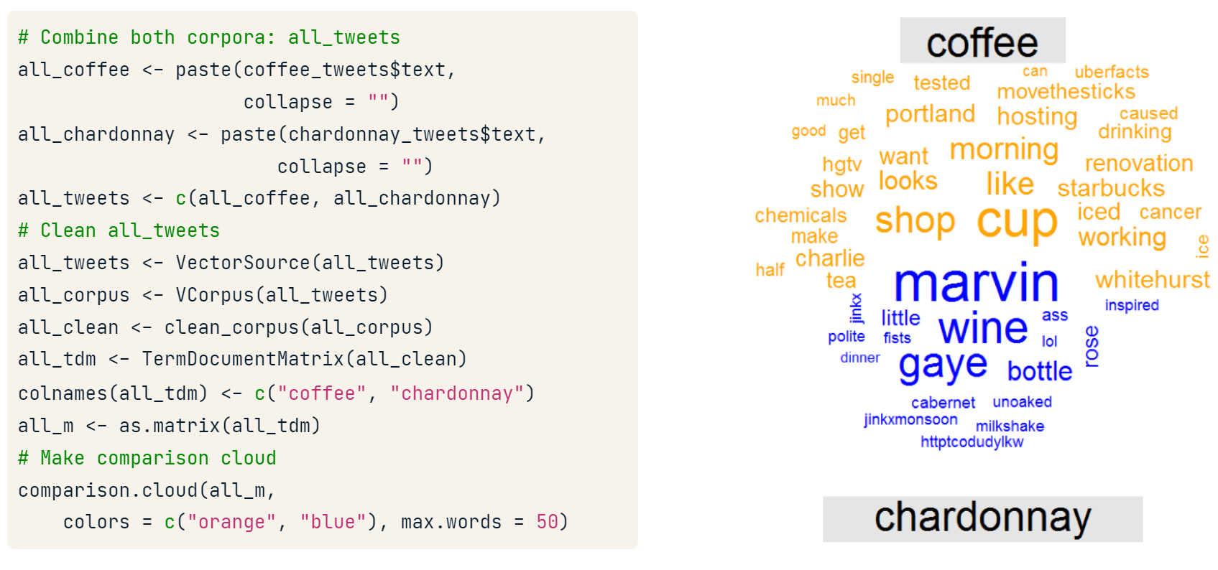

moby_tidy <- moby %>%

  inner_join(nrc, by = c("term" = "word")) %>%

  filter(!grepl("positive|negative", sentiment)) %>%

  count(sentiment, term) %>%

  spread(sentiment, n, fill = 0) %>%

  data.frame(row.names = "term")

# Plot comparison cloud

comparison.cloud(moby_tidy,

                 max.words = 50,

                 title.size = 1.5)

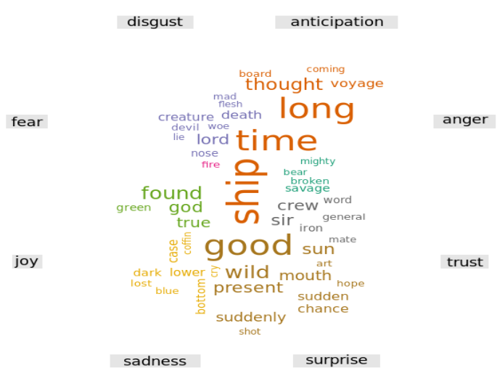

### pyramind plot

#### plotrix

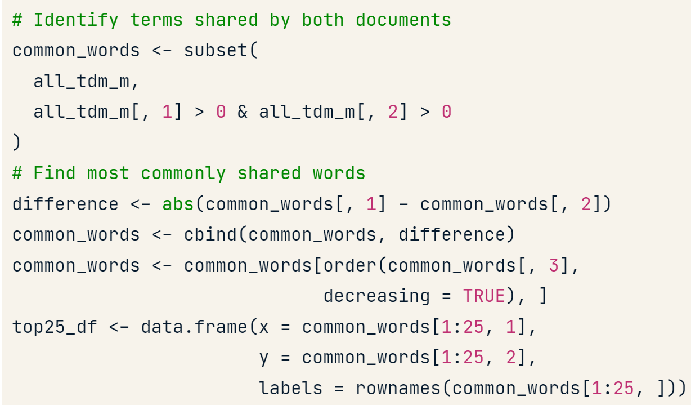

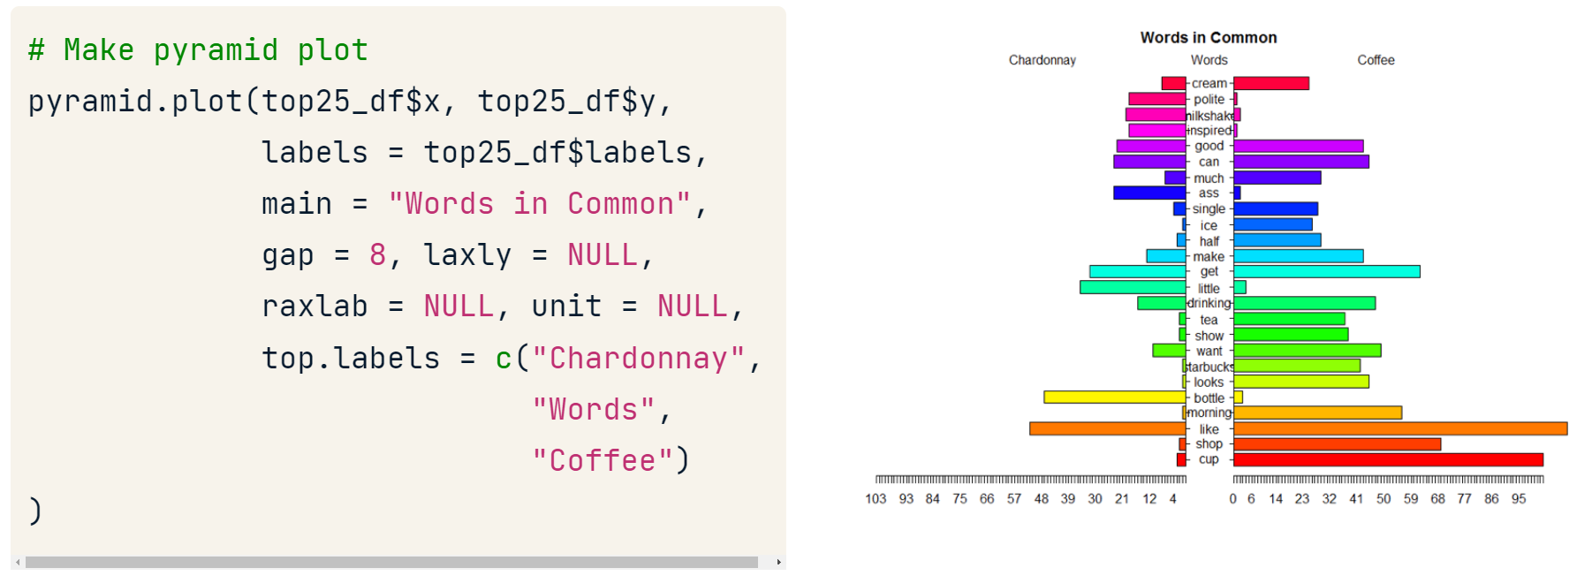

Or

pyramid.plot(word_count_data$count1,

word_count_data$count2,

word_count_data$word)

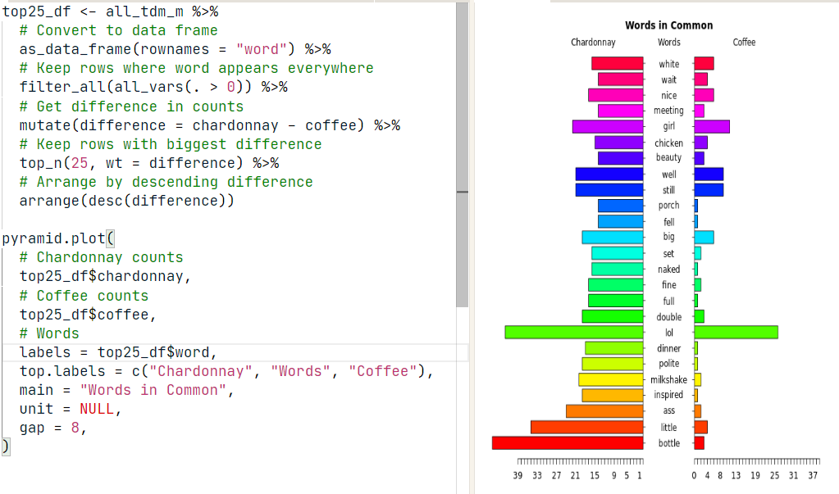

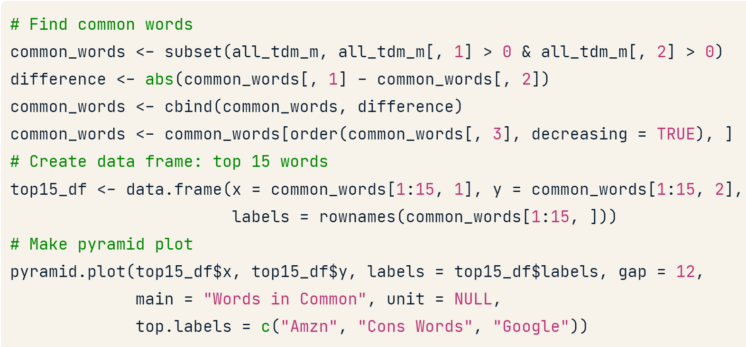

### Word network

#### qdap

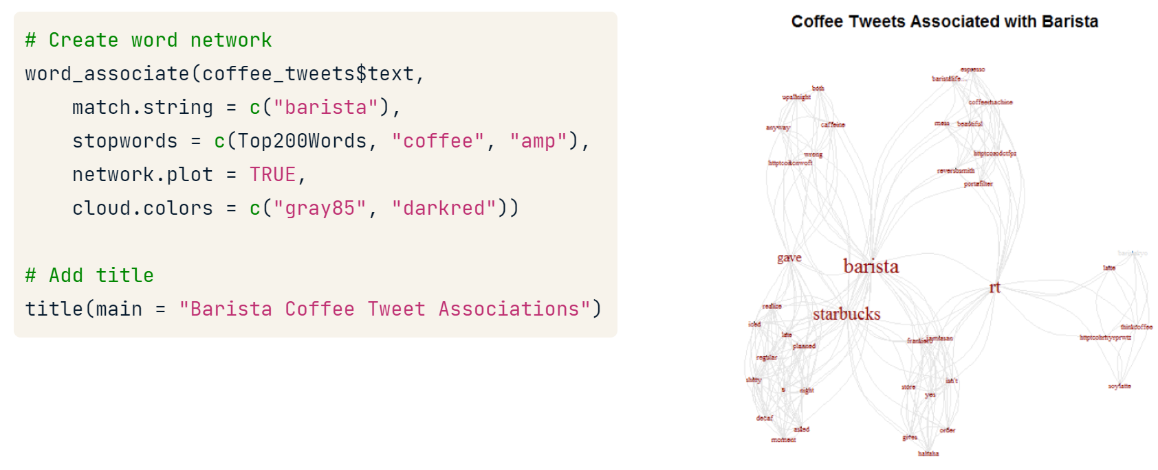

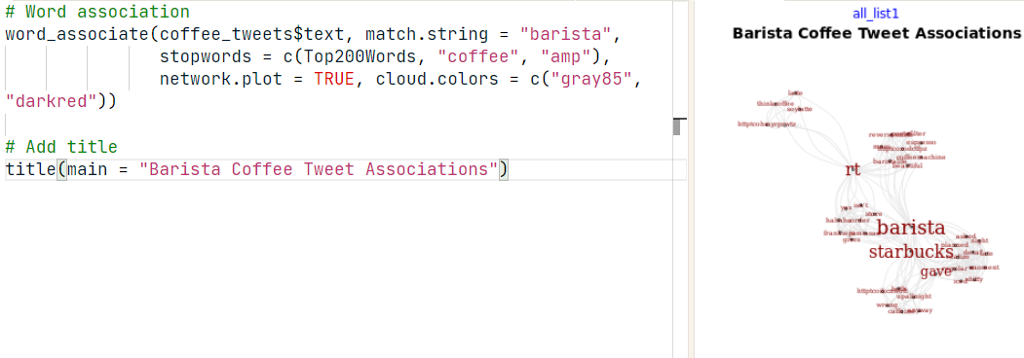

### Dendrogram (hierarchical clustering)

#### For number

dist takes every row as an unique element

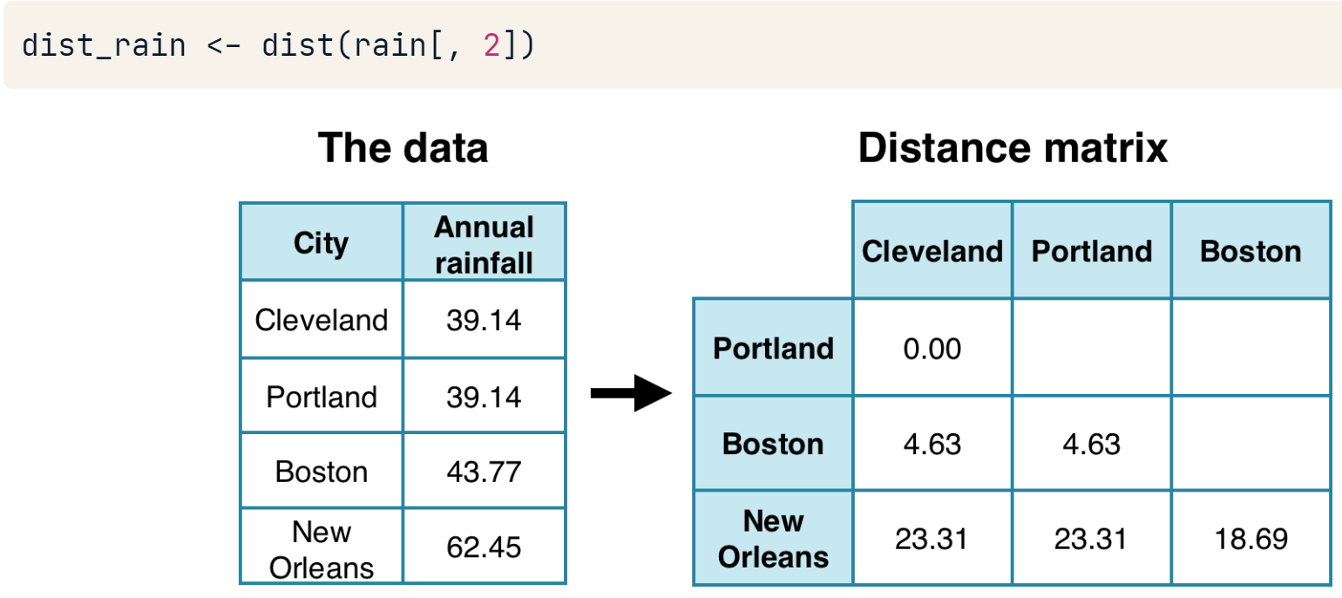

dist_rain object is passed to hclust to create a hierarchical cluster object

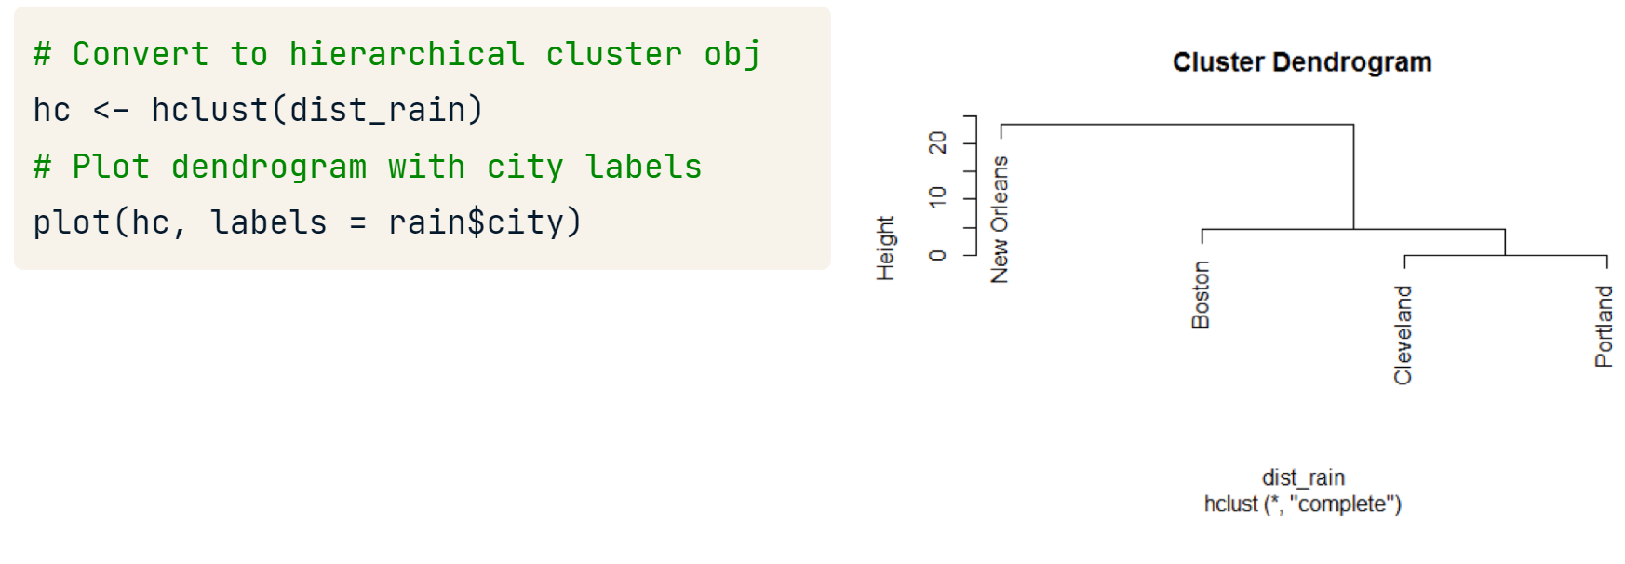

#### For words

rain is a term-document matrix

A good dendrogram is based on a TDM with 25 to 70 terms

**removeSparseTerms(),** the sparse parameter will adjust the total terms kept in the TDM. The closer sparse is to 1; the more terms are kept. This value represents a percentage cutoff of zeros for each term in the TDM.

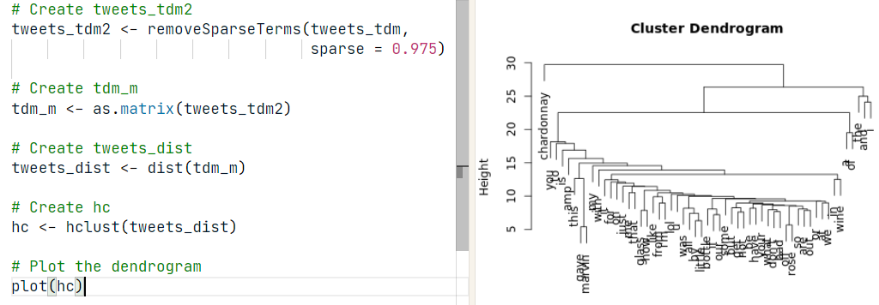

**labels()** function. It will print all terms of the dendrogram.

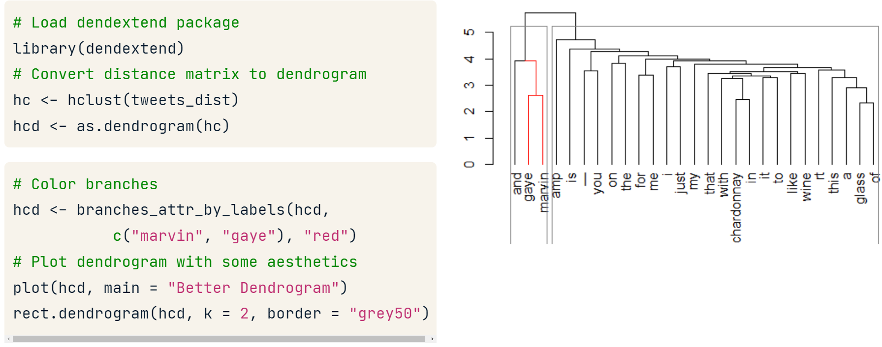

### Treemap

<https://yjunechoe.github.io/posts/2020-06-30-treemap-with-ggplot/>

## Latent Dirichlet allocation

The latent Dirichlet allocation topic model or LDA searches for patterns of words occurring together within and across a collection documents, also known as a corpus. Imagine again our bag-of-words. LDA finds topics in a corpus by creating a separate bag for each document and dumping the words out to look for patterns in which words appear together -- not just in one bag, but consistently across all the document-specific bags in our corpus.

Common **clustering techniques** like k-means and hierarchical clustering are based on the distance between objects, which is a continuous measure. Furthermore, each object being clustered is assigned to a single cluster. **Topic models like LDA** are based on word counts, which is a discrete measure. Furthermore, each object (in this case, a document within a corpus) is a mixture or partial member of every topic.

Note that since the topics are word probabilities, the sum of all probabilities for each topic equals 1. Also, since each topic includes every term in the corpus, the counts are equal across topics.

### Document term matrices

#### tidytext

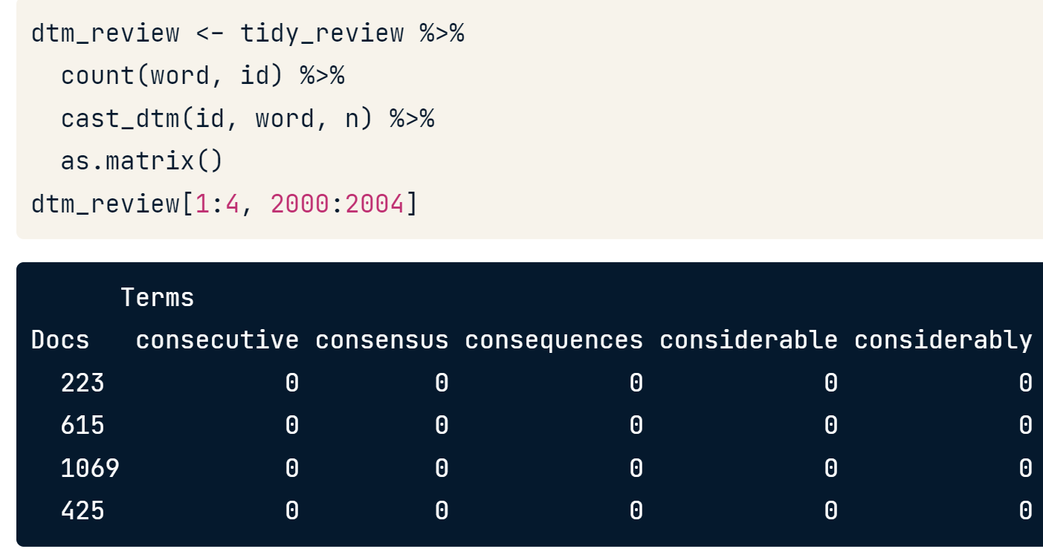

### Running topic models

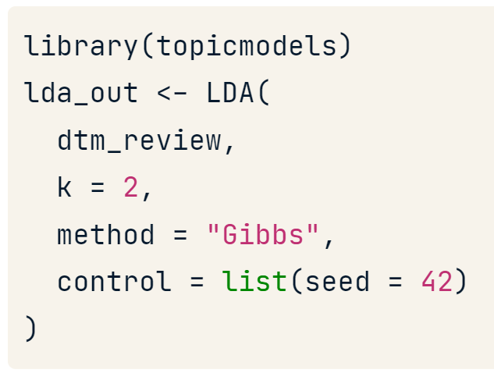

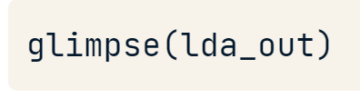

**k**, the number of topics we specified,

**beta**, the word probabilities that define the topics.

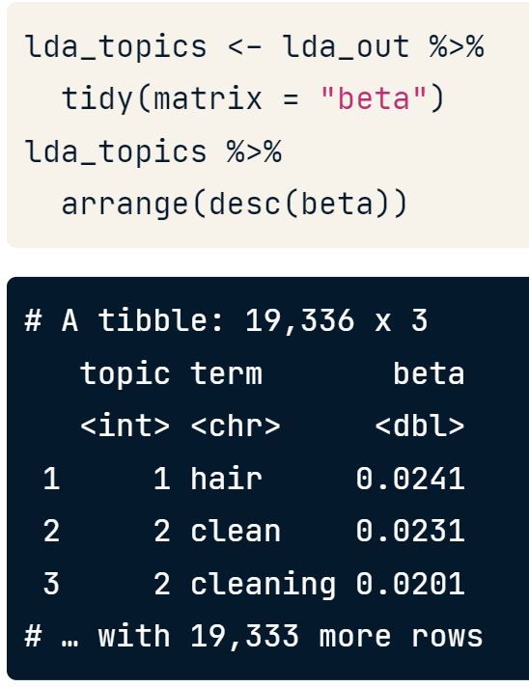

As we added topics, we saw more granularity, with each new topic adding something specific. ***Once we arrived at the point where adding a new topic appeared to simply duplicate an existing topic, we know we’ve gone too far***. Finally, we name the topics based on what the words with high probability appear to be indicating.

## Projects to complete

Text Mining America's Toughest Game Show

Going Down to South Park: A Text Analysis

A Text Analysis of Trump's Tweets